**EMAIL AUTO RESPONDER**

**ROBOT**

*Instantly responds to emails with pre-set messages, saving time and ensuring prompt communication.*

***ABSTRACT***

*Robotic Process Automation (RPA) is an emerging technology that has revolutionized the way businesses operate. It involves the use of software robots to automate repetitive, rule-based tasks, freeing up employees to focus on more strategic work.*

*Email-auto responder robots are a specific application of RPA, designed to automatically respond to emails based on predefined rules. This technology can greatly improve efficiency and productivity in organizations with high email volumes, reducing response times and ensuring consistent communication with customers.*

Table of Contents

1. **INTRODUCTION**………………………………………………………4
   1. Objectives…………………………………………….……………4
   2. What is an Email Auto-Responder Robot…………………………4
   3. Methodology………………………………………………………5
2. **IMPLEMENTATION**…………………………………………….……6
   1. Workflow…………………………………………………….……6
   2. Process Overview………………………………………...……….7
3. **RESULTS**………………………………………………………………10
4. **BENEFITS OF USING EMAIL AUTO-RESPONDER** **ROBOT**….12
5. **CHALLENGES**…………………………………………………….…13
6. **CONCLUSION**……………………………………………………..…14
7. **REFERENCE**…………………………………………………………14

**1. INTRODUCTION**

Email-auto responder robots are designed to automatically send pre-written responses to incoming emails, saving you time and ensuring that your customers receive timely replies. This technology is a game-changer for any organization looking to improve their customer service and streamline their communication processes.​

* 1. **Objective**

The objectives of this report are to introduce the concept of email-auto responder robots by RPA and explain why it is important for organizations to adopt this technology. These robots are designed to automate the process of responding to emails, which can save companies a significant amount of time and resources. By using an email-auto responder robot, organizations can ensure that their customers receive timely responses to their inquiries, which can improve customer satisfaction and loyalty.

In addition, implementing an email-auto responder robot can also help organizations streamline their operations and reduce costs. By automating the process of responding to emails, companies can free up their employees' time to focus on more high-value tasks. This can lead to increased productivity and efficiency, which can ultimately result in higher profits for the organization.

* 1. **What is an Email Auto-Responder Robot**

An email auto-responder robot is a software program that automatically replies to incoming emails based on predefined rules. These rules can include keywords, sender information, or other criteria that the user specifies. The robot analyzes each incoming email and sends an appropriate response without any human intervention.

The use of email auto-responder robots can greatly improve efficiency in organizations by reducing the workload of employees who would otherwise have to manually respond to each email. Additionally, these robots can be programmed to provide personalized responses, improving customer satisfaction. Overall, email auto-responder robots are a valuable tool for any organization looking to streamline their email communication process.

* 1. **Methodology**

To create an email responder robot using Robotic Process Automation (RPA), you can follow the following methodology

1. Define the scope and requirements: Determine the specific functionalities and capabilities of the email responder robot. Identify the types of emails it should handle, the responses it should provide, and any additional requirements such as integration with email clients or databases.

2. Design the process flow: Map out the sequence of steps the robot will follow to handle incoming emails and generate responses. Define the decision-making logic, error handling mechanisms, and any required data inputs or validations.

3. Select an RPA tool: Choose an RPA tool that supports email automation capabilities. Consider factors such as ease of use, compatibility with email clients, and the ability to integrate with other systems if required.

4. Set up email integration: Configure the RPA tool to connect with the email client or server that will be used to receive and send emails. This may involve setting up email account credentials, defining email filters or rules, and enabling access to the email inbox

5. Develop the automation workflow: Use the selected RPA tool's visual or script-based development environment to create the automation workflow. This involves defining activities such as email retrieval, reading email content, analyzing email data, generating responses, and sending replies.

6. Test and debug: Thoroughly test the email responder robot in various scenarios to ensure it functions as expected. Validate that it retrieves emails correctly, generates accurate responses, and handles errors or exceptions appropriately. Debug any issues that arise during testing.

1. **IMPLEMENTATION**
   1. **Workflow**

The first step in implementing an email auto-responder robot using RPA is to identify the processes that can be automated. This involves analysing the existing email communication workflows and identifying the repetitive tasks that can be automated. Once these tasks have been identified, the next step is to the design workflow for the email auto-responder robot. This involves mapping out the steps that the robot will take to respond to emails and ensuring that the workflow is optimized for efficiency.

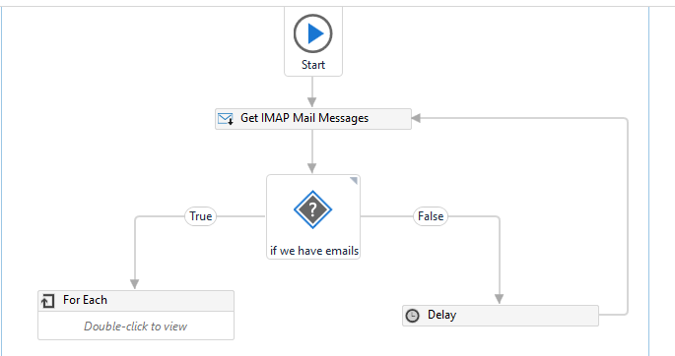

Figure 1: Process Flow

2.2 **Process Overviews**

Step 1: Create new process and name it as “**Auto-responder Robot**”.

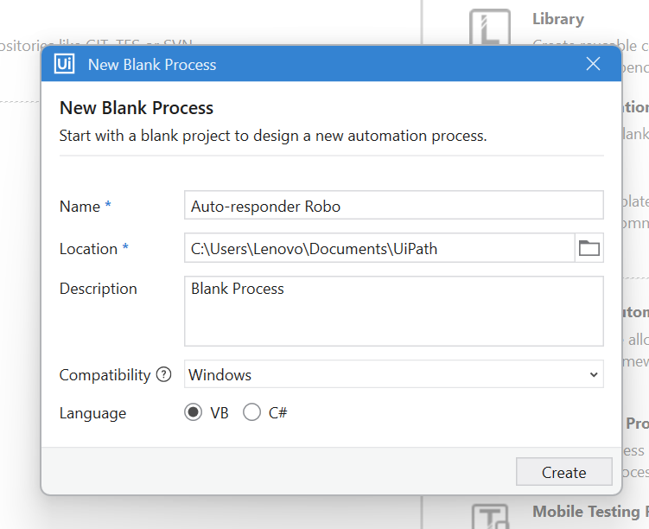

Step 2: Drag **Get Password** activity and set password.

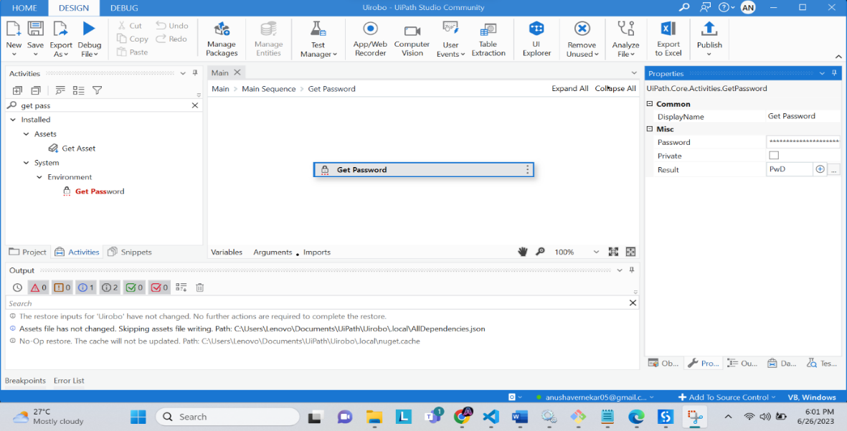

Step 3: **Get IMAP Mail Message** to read the messages. Set properties like Port number, sever, email and password. Once we read the message or mail that need to be stored in variable, variable” MailCollector” store all email.

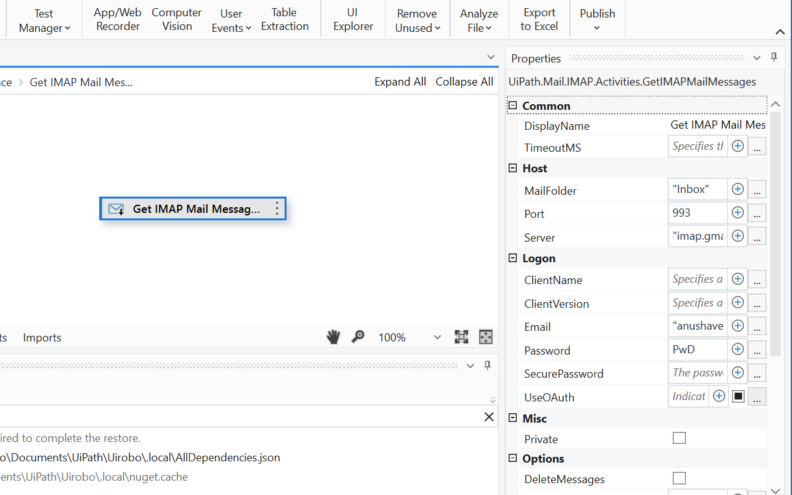

Step 4: Drag **For each** and set properties. Drag **Send SMTP Mail Message** to reply customer/sender.

Set parameters like TO, SUBJECT, BODY.

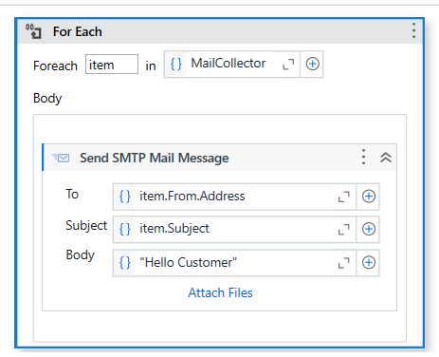

1. **RESULTS**

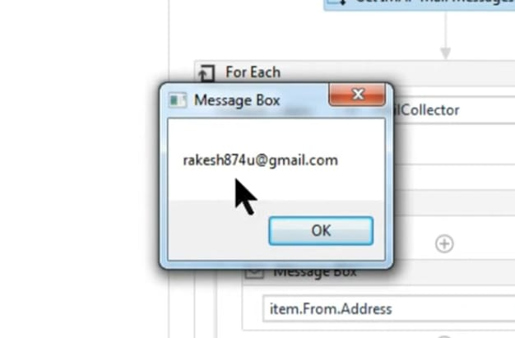

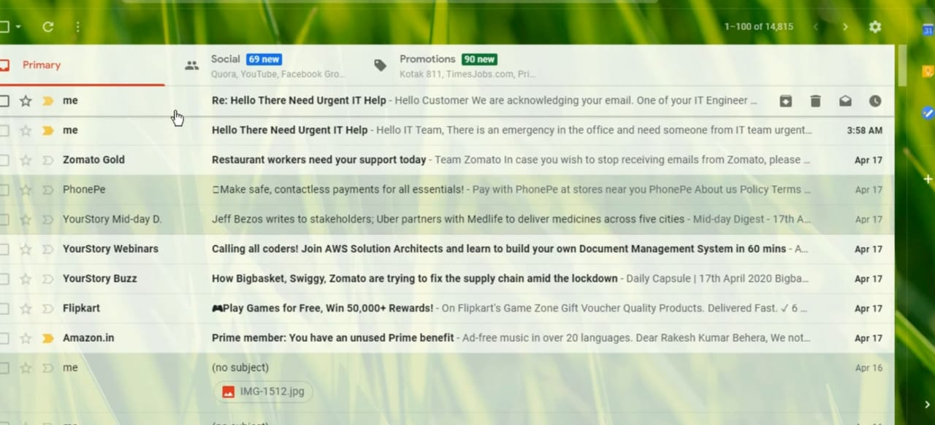

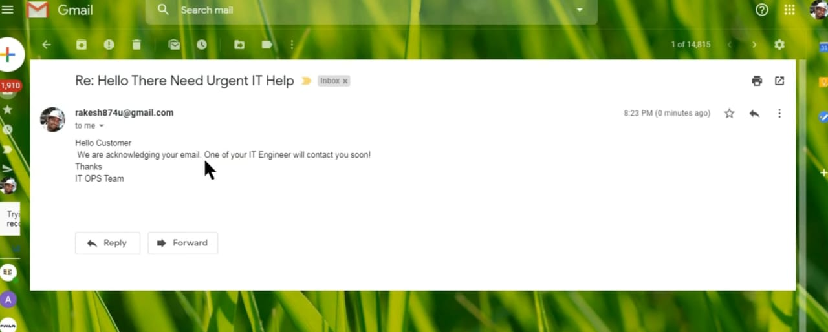

1. **BENEFITS OF USING EMAIL AUTO-RESPONDER ROBOT:**

Implementing an email auto-responder robot using RPA can provide numerous benefits to organizations. Firstly, it can significantly increase efficiency by automating the process of responding to emails. This means that employees can focus on more important tasks and not waste time on repetitive and mundane activities.

Secondly, implementing an email auto-responder robot can improve customer satisfaction by providing prompt responses to inquiries and requests. This can lead to increased loyalty and positive word-of-mouth recommendations. Finally, it can also reduce workload by handling a large volume of emails without the need for additional staff.

1. **Challenges and Solutions:**

One of the biggest challenges when implementing an email auto-responder robot using RPA is ensuring that the responses are personalized enough to meet the needs of each individual customer. While automation can certainly speed up the process, it can also lead to generic, impersonal responses that don't address the specific concerns of the customer. To overcome this challenge, it's important to use machine learning algorithms that can analyse customer data and generate responses that are tailored to their unique needs.

Another challenge that organizations face when implementing an email auto-responder robot using RPA is ensuring that the technology integrates seamlessly with existing systems. This can be particularly challenging if the organization is using legacy systems that aren't designed to work with modern automation technologies. To overcome this challenge, it's important to work with experienced RPA providers who can help integrate the technology into existing systems and ensure that everything is working together smoothly.

1. **Conclusion**

In conclusion, we have explored the concept of email auto-responder robots using RPA and how they can benefit organizations in terms of increased efficiency, improved customer satisfaction, and reduced workload. By implementing this technology, businesses can streamline their email communication processes and provide better service to their customers.

However, it is important to keep in mind the challenges that may arise when implementing an email auto-responder robot using RPA. These include potential errors in the automation process and the need for ongoing maintenance and updates. Nonetheless, with proper planning and execution, these challenges can be overcome.

In the end, the benefits of using email auto-responder robots using RPA far outweigh the challenges. We encourage you to consider implementing this technology in your own organization and experience the positive impact it can have on your business operations.

1. **Reference**

<https://rpamaster.com/rpa-for-reply-to-emails/>

<https://www.geeksforgeeks.org/robotic-process-automation-rpa-email-automation->using-uipath/